David Lambertson

Quality Model

Application

My model will be called the Student Quality Model. Many models are structured around projects continuing and being added upon. Student projects are usually not like this. Once a project is finished, the student moves on due to other classes or work. Because of this, not many models are that well suited for student projects. You can still use them but you usually have a major part of it you ignore or let it slide.

With a student project, there are some key points you need to focus on though. According to the terminology used in the article the key points would be: Acceptance, Accuracy, Appropriateness, Configurability, Fault Tolerance, and Reliability. Using these, I can make a few groups which are product review (acceptance, accuracy, appropriateness) and product usability (configurability, fault tolerance, and reliability). Using these attributes above, I believe a student could

Present the Model

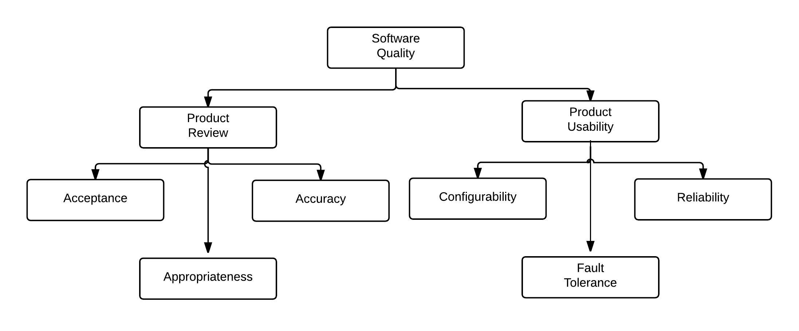

Figure

Rationale

I chose these as my criteria because I was thinking of making a model specifically designed for students. A lot of student projects do not go to live past the semester. Due to this, I chose to leave these above because these are the things a student’s project should have. It allows them to test the product as if it would be used by users and distributed, just not maintained.